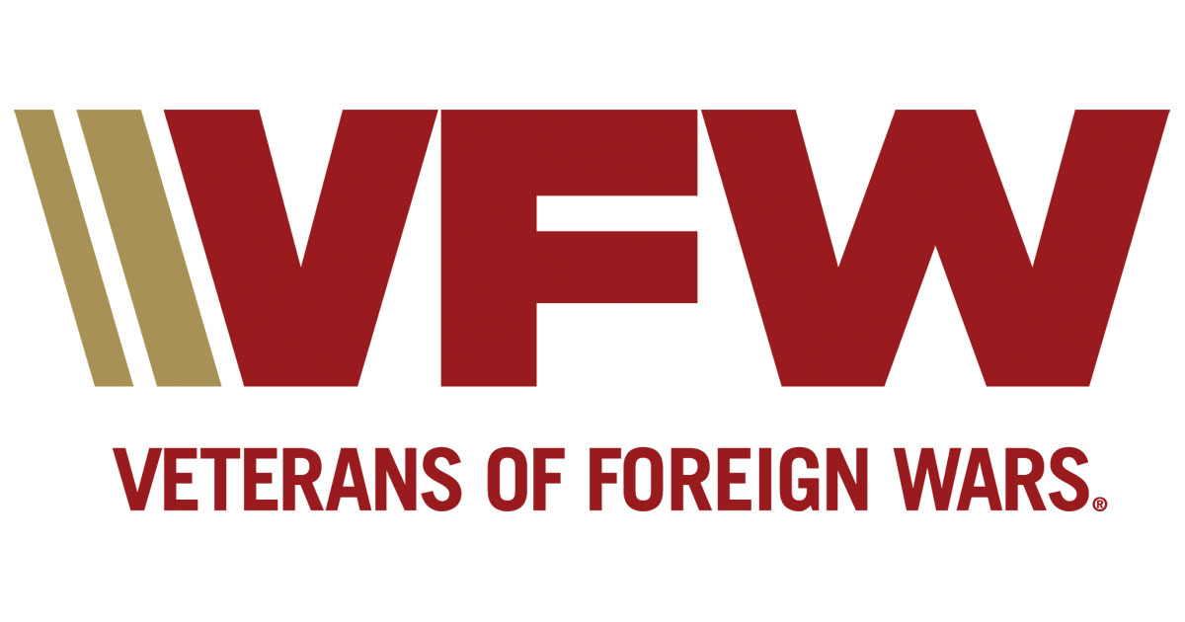
Meridian Post 4000
Meridian Senior Center - 1920 N Records Ave.
Meets 2nd Tuesday of Month at Kleiner Park
Post website www.vfw4000.org

September 8, 2020 Post Meeting Minutes

Post Officers for 2020-2021 Post Auxiliary
Commander: Tammy Clement President: Carol Williams
Senior Vice Commander/Adj: Bob Wheeler Secretary: Melissa Suekel
Jr. Vice Commander: Brian Puckett
Quartermaster: Troy Junier

Dates and Events Coming Up:
District Meeting – Sept 19, 2020, 12:00 lunch, 1:00pm meeting, - Post 142, Idaho City, Boise
VA CLC Bingo – CLC @ Veterans Hospital, Boise, ID- Pending State COVID Guidelines
Post Meeting – Oct 13, 2020, 7:00 p.m. - 1920 N. Records Ave, Meridian Sr. Center, Kleiner Park

If you have an email rather than your personal home address to use, it would be beneficial. Many changes can happen where there is not enough time to mail out and the additional costs to the post.

Meeting Minutes for September 8th, 2020 – Commander also conducted Zoom meeting for post due to COVID Restrictions.
7:01 p.m. Opening of Meeting - by Post Commander.
7:05 p.m. Roll Call of Officers – 8 Officers, 1 member.
7:06 p.m. Membership Applications- No new memberships.
7:06 p.m. Reading of the Minutes for Aug 11th, Meeting – Motion made to accept as written by Mike
Clement, 2nd Brian Puckett, motion passed.
7:07 p.m. Quarter Master Report – Motion made to accept the corrected QM report of .85 that was missing on the $37.85 deposit of the Honor Guard in July by Brian Puckett, 2nd by Hugh Fryling, motion passed. Total in Checking for Aug $9,941.89, Savings $2,004.17. Motion to accept as read by Brian Puckett, 2nd by Hugh Fryling, Motion passed.
7:10 p.m. Service Officer Report – Draping of the Charter for comrades Michael Dessert and Fred Hall.
7:15 p.m. Community Reports: Honor Guard: -Tammy discussed Honor Guard practices will be on Sep 12th from
11:00-12:30, and on Sep 20th 1:00-2:30. Honor Guard Meeting on Sep 24th @ 6:30 at Veterans Memorial Hall. Recruiting is a high priority.
- CAR Report: Members 38 Hours 105.25 Miles 355.5 Money/Donations $558.00
- Do not forget to send your Community Activity Reports to Bob Wheeler @ Post4000@vfwid.org by the 24th. If you miss the deadline send them anyway so they can get added to next month’s report.
- Post is currently 2.35% for membership.

Blessing of the National Home Prayer
7:17 p.m. Unfinished Business – Troy mentioned the Nampa Gun Show schedule and asking for volunteers for Sept 13th.
7:19 p.m. New Business – Toys for Tots Campaign are needing volunteers this holiday season! If you would like to volunteer, contact Carolyn Black (308)453-4977.
7:26 p.m. Good of The Order
- Commander discussed the General Orders.
- Commander in Chief Challenge – for the month of September 2020, the Post in each membership division that recruits, renews, and reinstates the most annual members will receive a $500 stipend deposited into the Post account. In addition, each Department with a winning Post will receive a matching $500 to be deposited in the Department Fund.
- Commander discussed the post to pay for membership for those members who are 80 years of age and above after contacting the members first. Motion made by Brian Puckett, 2nd by Troy Junier. Motion passed. Discussion to review membership for members 79 years of age and below, offering to pay $14 of the $28 at next month’s post meeting.
- Voice of Democracy applications have been distributed to Eagle, Meridian and Renaissance schools by June Pack. Patriots Pen applications will soon be distributed.
- National Suicide Prevention Month – The American Foundation for Suicide Prevention will be hosting the “Idaho Out of the Darkness Experience” on Oct 10th. For more information contact Devin Jordan (208)391-3235.
- Whitewater Oral Surgery Group is launching their first Smiles for Soldiers Program which would provide a full-arch restoration to an active duty member or veteran in our community. Contact them at (208)342-7610.
- USS Idaho SSN 799 – The commissioning Foundation is searching for citizen volunteers and veteran volunteers that would provide a good fit between experience and the position needs. For more information contact Richard Fife (208)260-0364 or email rfife601g@gmail.com
- Senator Crapo’s office is now accepting 2020 Spirit of Freedom nominations for worthy veterans and veteran volunteers. Please send the Commander your nomination forms as soon as possible, as the nominations forms needs to be at the Senator’s office by October 9th.
- Boise VA – There will be no walk-in flu clinics this year due to COVID. Flu shots will be available Sep 21 to Oct 16 (Mon-Fri), 9:00am – 3:00pm.
- There is a need for volunteers to help with traffic control and screening. The hours of operation are 0630-1600 M-F and it is broken into two-hour shifts. If you are interested contact Tammy Lanning at (208)422-1000, Ext 1175.
- Raffle tickets are still available, contact Commander or Quartermaster for additional tickets.
8:01 p.m. Closing Ceremonies - by Post Commander, the next Meeting is scheduled for Oct 13th, 2020.

Notes and Information from the VFW Department of Idaho:
- Post members are to be in current good standing with membership in the VFW to be an officer in the post and should have on file DD-214’s on file for verification of qualification for VFW membership.

-District Meetings: -
September 19, 2020, Post 142, Idaho City
December 12, 2020, Post 4000, Meridian
March – Post 7019, Kuna

