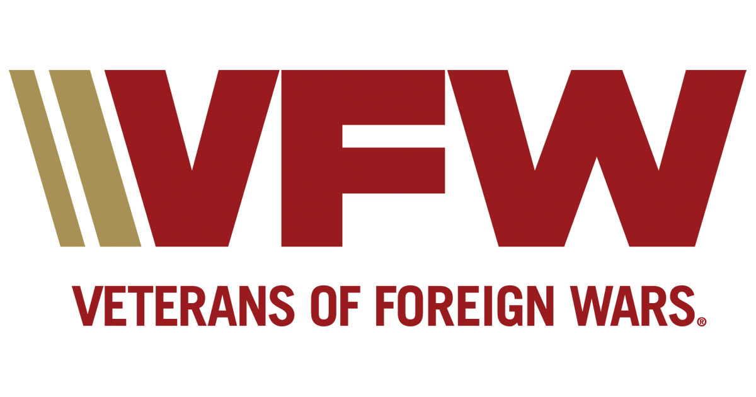
Meridian Post 4000
Meridian Senior Center - 1920 N Records Ave.
Meets 2nd Tuesday of Month at Kleiner Park
Post website www.vfw4000.org

October 13, 2020 Post Meeting Minutes
Happy Halloween

Post Officers for 2020-2021 Post Auxiliary
Commander: Tammy Clement President: Carol Williams
Senior Vice Commander/Adj: Bob Wheeler Secretary: Melissa Suekel
Jr. Vice Commander: Brian Puckett
Quartermaster: Troy Junier

Dates and Events Coming Up:
District Meeting – Dec 12, 2020, 12:00 lunch, 1:00pm meeting, - Post 4000, Meridian
VA CLC Bingo – CLC @ Veterans Hospital, Boise, ID- Pending State COVID Guidelines
Post Meeting – Nov 10, 2020, 7:00 p.m. - 1920 N. Records Ave, Meridian Sr. Center, Kleiner Park

If you have an email rather than your personal home address to use, it would be beneficial. Many changes can happen where there is not enough time to mail out and the additional costs to the post.

Meeting Minutes for Oct 13th, 2020 – Commander also conducted Zoom meeting for post due to COVID Restrictions.
7:00 p.m. Opening of Meeting - by Post Commander.
7:03 p.m. Roll Call of Officers – 7 Officers, 4 members.
7:05 p.m. Membership Applications- No new memberships.
7:05 p.m. Reading of the Minutes for Sep 8th, Meeting – Motion made to accept as written by Troy Junier, 2nd Don Black, motion passed.
7:06 p.m. Quarter Master Report – Motion made to accept the corrected QM report of a $2.00 discrepancy in August by Don Black, 2nd by Mike Clement, motion passed. Total in Checking for September $9,528.15, Savings $2,004.17. Motion to accept as read by Don Black, 2nd by Hugh Fryling, motion passed.
7:09 p.m. Service Officer Report – Draping of the Charter for comrade Oscar Rogers. Member Duane Sammons has suffered a major heart attack and is in serious condition. Also remember Member Arnold Stewart a WWII Veteran is also not doing well. Please keep them and their families in your thoughts and prayers.
7:13 p.m. Community Reports: Honor Guard: -Tammy discussed Honor Guard practices will be on Oct 17th from
11:00-12:30, and on Oct 22nd from 1:00-2:30. Honor Guard Meeting on Oct 22nd @ 6:30 at Veterans Memorial Hall. Recruiting is a high priority.
- CAR Report: Members 26 Hours 69.40 Miles 406.5 Money/Donations $669.00
- Do not forget to send your Community Activity Reports to Bob Wheeler @ Post4000@vfwid.org by the 24th. If you miss the deadline send them anyway so they can get added to next month’s report.
- Post is currently 71.37% for membership.

Blessing of the National Home Prayer
7:15 p.m. Unfinished Business – None to report.
7:15 p.m. New Business – None to report.
7:16 p.m. Good of The Order
- Commander discussed General Orders #4.
- The Department of Wyoming has continued planning the conference as scheduled, November 6-8.
- Mid-Winter is tentatively scheduled for January 8-10, 2021. Registration deadline is December 30,
2020.
- Membership Program Change – Requirement to purchase Buddy Poppies has been removed from the
Post Criteria to achieve All-American.
- Commander in Chief Challenge – for the month of October 2020, the Post in each membership division with the highest increase in total membership percentage between Oct 1st and Oct 31st will receive a $1000 stipend deposited into the Post account.
- 2020 Homeless Veterans Stand Down – the deadline for the registration form was Oct 13th, however if you know of a homeless veteran in need, I will contact the Stand Down Committee and Partners to ask for assistance.
- Wreaths Across America – State House Ceremony will be December 14th, 2020 @ 10am on the Idaho State Capitol Steps, National Remembrance Ceremony will be held December 19th, 2020 @ 10am located at the Idaho State Veterans Cemetery. Motion to purchase 5 wreaths made by Mike Clement, 2nd by Lee Castleman, motion passed.
- Boise VA – There will be no walk-in flu clinics this year due to COVID. Flu shots will be available Sep 21 to Oct 16 (Mon-Fri), 9:00am – 3:00pm.
- Veteran Sponsorship Program – I would like the post to sponsor a veteran this holiday season. Boise VA will be sending out forms end of Oct, early Nov.
- Ada County United Veterans Council – Boise VA Regional Office has reopened to the public. Burial plot allowance is up $11.00. The new rate is $807, from the previous $796.00. (This is for spouses of Veterans). VHA update- the VA was ordered to reimburse Veterans for all past and future out of pocket emergency medical bills not covered by private insurance other than co-payments. Veterans should send in all proof of claims and/or denials regarding outside medical/health care for non-VA emergency visits.
- Keystone Hospice will be donating Thanksgiving dinners with all the trimmings to Veterans. Meals can be delivered to their home if needed and all precautions will be taken.
- Boise Rescue Mission and Kevin Miller Event – November 16-21, located at the Walmart in Nampa will be asking for donations for turkeys. Tabled the motion to purchase turkey until the next post meeting in November.
- Veterans Day Ceremony – Post 4000 and American Legion will be conducting the ceremony at the Rock of Honor, Kleiner Park at 11am. Let us all try to attend!
- Operation Grateful Hearts – raffle and pumpkin sales booth starting at 8am on Saturdays Oct 17th and Oct 24th, located on the corner of Chinden & Linder. 100% of sales goes to local Veterans & military families.
- Panda Express Program – coming soon! The post will register and receive 28% of the profits. More information to follow on the exact dates.
- Raffle tickets are still available, contact Commander or Quartermaster for additional tickets.
7:58 p.m. Closing Ceremonies - by Post Commander, the next Meeting is scheduled for Nov 10th, 2020.

Notes and Information from the VFW Department of Idaho:
- Post members are to be in current good standing with membership in the VFW to be an officer in the post and should have on file DD-214’s on file for verification of qualification for VFW membership.

-District Meetings: -
December 12, 2020, Post 4000, Meridian
March – Post 7019, Kuna

